MILESTONE EVALUATION SHEET

MILESTONE NO.
5

DATE: | COURSE NO.: ISMG 6060
 | INSTRUCTOR: Ersin Dincelli

TEAM NO. OR NAME | TEAM MEMBERS
 | Yash Nigam

Student comments:

Instructor comments:
CRC card
Need to indicate the class type as domain as well.
Need to indicate data type of attributes.
Class Diagram
Need to include all responsibilities listed on the CRC card as operations on the class diagram.

Score:10
CRC Card

For PSSM staffing solution, there are three classes
1.Contract
2.Candidate
3.StaffingRequest

Front:
Class Name: Contract | ID: 1 |  | Type: Concrete
Description: This class describes the contracts negotiated between the client and PSSM staffing agency |  |  | Associated Use Cases: 3
Responsibilities  Responsibility1  Addition to the consolidated contract table  Assigned to the staffing request  Assign to PSSM candidate (another department)  Add the candidate |  | Collaborators  Collaborator1  Database  StaffingRequest  Candidate  Candidate

Back:
Attributes:
Attribute1
Contract_ID
Contract_Date
Client_Name
Client_Address
Client_Phone
Client_Email
CandidateDetail

Relationships:
Generalization (a-kind-of):

Aggregation (has-parts):

Other Associations: Candidate,StaffingRequest

Front:
Class Name: Candidate | ID: 2 |  | Type: Concrete
Description: This class represents the available candidate details visible to the client and PSSM using consolidated database. |  |  | Associated Use Cases: 3
Responsibilities  Responsibility1  Added_Employee  Added to contract  Hold/reserve  Place |  | Collaborators  Collaborator1  Database  Contract  StaffingRequest  StaffingRequest

Back:
Attributes:
Attribute1
EmpID
EmpStatus
EmpName
EmpAddr
EmpPhone
EmpEmail
Experience
Qualification
Expected Salary
ContractID

Relationships:
Generalization (a-kind-of):

Aggregation (has-parts):

Other Associations: Contract, StaffingRequest

Front:
Class Name: StaffingRequest | ID: 3 |  | Type: Concrete
Description: This class represents staffing request used to manage placements for PSSM clients and candidates. |  |  | Associated Use Cases:
Responsibilities  Responsibility1  Add to table  Assign to contract  Reserve candidate  Place candidate  Close |  | Collaborators  Collaborator1  Database  Contract  Candidate  Candidate  Database

Back:
Attributes:
Attribute1
RequestID
Status
ContractID
Description
Experience reqst
Qualification reqst
Salary Offered
Reserved Candidate
Placed Candidate

Relationships:
Generalization (a-kind-of):

Aggregation (has-parts):

Other Associations: Contract, Candidate

Class Diagram

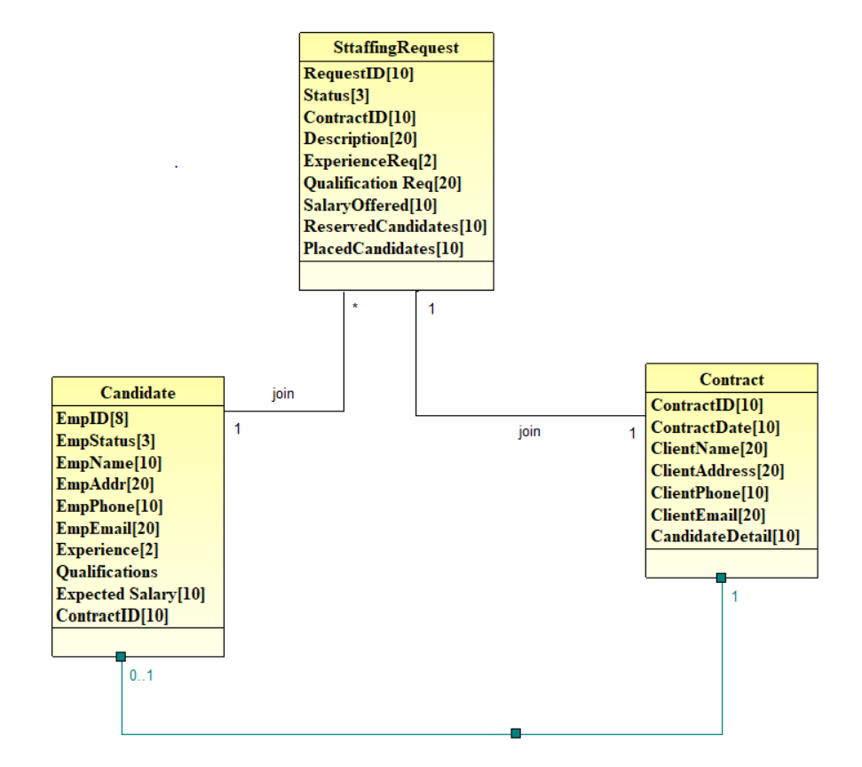

Verification and Validation for Functional model

-CRC cards→Classes on the class diagram
-CRC card responsibility→Operation on class diagram
-CRC card attributes→Class diagram attributes
-CRC relationships→Notations are appropriate
-CRC card collaborators→CRC card relationship and class diagram association
-Classes reflect unique characteristics about intersection of connecting classes.

